**QUESTION 2. BUILDING A PREDICTIVE CUSTOMER CHURN MODEL USING REGRESSION ANALYSIS MODEL**

Churn is a scourge on subscription businesses. There is a way to predict at least to some degree how and when your customers will cancel the subscription. Regression Algorithm as a machine learning techniques can be use.

Building a predictive churn model helps you make proactive changes to your retention efforts that drive down [churn rates](https://www.profitwell.com/customer-churn/calculate-churn-rate)

A churn model is a mathematical representation of how churn impacts your business. Churn calculations are built on existing data, the number of customers who left your service during a given time period This helps you predict your revenue and avoid risks like overspending.

Data need to build a churn model

Customer Information: These includes

* customer’s name

### address

### job title,

### employment status,

### team size

### Purchasing Power : This includes

### Purchase history

### billing history.

* when a customer signed up
* when they canceled service,
* their payment history,

STEPS

### **1. Data Gathering and review**

Every bit of customer information you have is a valuable data point in the upcoming churn calculations. Make sure you review all of your data for accuracy and validity before moving on to the building model

### **2. Set up a regression formula**

Mathematical modeling for churn is built on a statistical process called logistic regression. This process determines the relationships between points in your data set based on a formula and limits the outcome to between 0 and 1. You’ll take all the customer information, purchase history, SaaS metrics, and prior churn data and turn it into a statistical prediction of when certain types of customers might churn in the future.

Your formula and potential outcome will look like this:

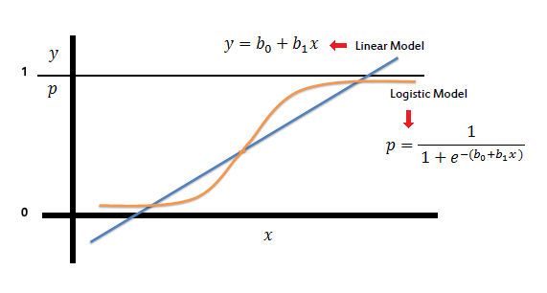

### **3. Come up with a retention plan**

Once churn is modeled through the logistic regression formula, you’ll be able to more clearly [analyze retention](https://www.profitwell.com/customer-retention/retention-analysis) and see the probability of certain customer segments churning.

To help maximize retention, use this information to formulate a plan, based on these findings, that targets each of your cohorts directly. The probability of certain customers churning your service earlier than others will make it easy to prioritize your actions.

### **4. Implement and track your results**

It’s time to implement retention strategy. keep track of how it impacts your churn rate over the next few months. Gather enough data to see the real impact of your efforts before making additional changes to your plan. This data might look something like this:

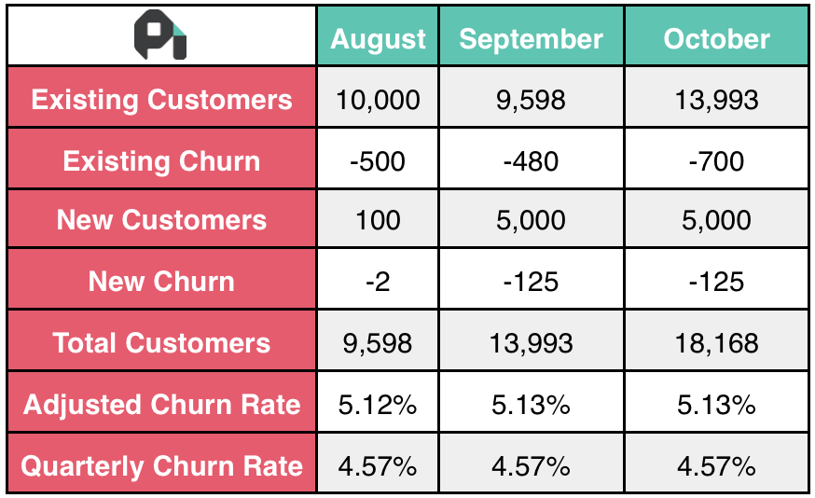

**5. Test retention strategies**

Churn model will provide probabilities for a number of different cohorts in your customer base. Make sure you’re always testing out new strategies and recording the impact on these customer segments. Each subsequent test can help one create a better model for the future.